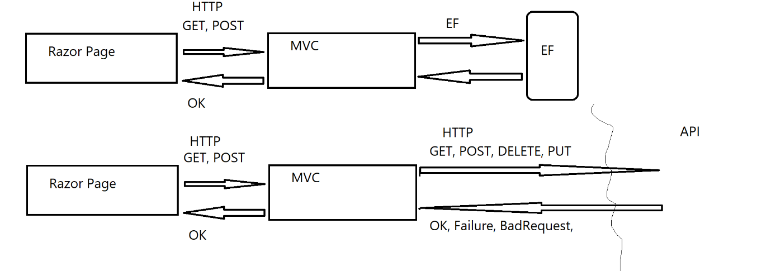

**Assignment**

1. In API Project create new API Controller HotelBooking and implement CRUD API interface using EF Core
   1. Create(Hotel hotel)
   2. Edit(Hotel hotel)
   3. Delete(int id)
   4. GetAll()
   5. Get(int id)
2. In MVC Project, create Controller and View to implement CRUD user interface with API backend